Approach Trade Study
Team: Hands-Free Reading, Team 24
Date: 10/06/26
We will be looking at your approach to your overall system with this document. A fundamental practice of engineers is the ability to take fully complex systems and break them down into smaller systems (called sub-systems) that are easier to process. Using your project, break it down into the number of functional blocks needed to complete the task. Then evaluate different approaches to your functional block. You will need to do this process for each of your project’s functional blocks.

Functional Decomposition:
￼

Functional Block: Page turning trigger
 | Accessibility  (Weight = 0.6) | cost  (Weight = 0.05 ) | Power consumption  (Weight = 0.05) | Portability (Weight = 0.1) | accuracy (weight = 0.2) | Total
Eye tracking | 3 | 1 | 1 | 3 | 2 | 1.88
Speech | 2 | 2 | 2 | 2 | 1 | 1.07
Foot pedal | 1 | 3 | 3 | 1 | 3 | 1.6
Table 1: Page turning trigger approach trade-offs, 3=best and 1=worst

Trade-Offs:
Eye tracking appears to be the best solution in terms of accessibility and portability, but cost is higher and it will consume a significant amount of power. Speech is average in terms of cost, power consumption, and portability, but it decreases how many people can use the product either due to speech impairment or environment limitations. The foot pedal is best in terms of cost, power consumption, and accuracy since the design is much simpler and has fewer false triggers, but it decreases how many people can use the product as well as motor function is required.

Decision: Eye tracking

Functional Block: Move page
 | Cost (weight = 0.2) | Damage Risk (weight = 0.3) | accuracy  (weight = 0.3) | Ease of implementation (weight = 0.2) | Total
Wheel | 4 | 1 | 1 | 4 | 2.2
arm | 4 | 3 | 1 | 2 | 2.4
wheel + arm | 3 | 4 | 4 | 3 | 3.6
Grippy finger | 1 | 2 | 3 | 1 | 1.9
Table 2: Move page approach trade-offs, 4=best and 1=worst

Trade-Offs:
The wheel and arm combination appears to be the best solution as it has the lowest damage risk and highest accuracy, but it is slightly more costly and difficult to implement. The wheel is good in terms of cost and ease of implementation since it is only a motor, but it risks the most damage. The arm is also good in terms of cost but ease of implementation isn’t as good since it is more difficult to separate pages. The grippy finger would be one of the most accurate solutions, but cost and implementation are worse since it would require a pressure sensor to detect how hard the finger needs to press to flip the page.

Decision: Wheel + arm

Functional Block: Receive Power
 | portability (weight = 0.4) | build cost (weight = 0.1) | user cost (weight = 0.2) | Capacity (weight = 0.3) | total
Wall Power | 1 | 3 | 3 | 3 | 2.2
rechargeable battery | 3 | 1 | 2 | 2 | 2.3
Single use battery | 2 | 2 | 1 | 1 | 1.5
Table 3: Receive power approach trade-offs, 3=best and 1=worst

Trade-Offs:
The rechargeable battery approach seems to be the best solution as it allows portability and reduces user cost since the batteries don’t need to be replaced often, but the tradeoff is that it must be charged between uses. Wall power was the second best approach since it is most cost effective and doesn’t require the user to take breaks between uses for charging, but portability is very minimal since the user must be in cord distance to the outlet. A single use battery is the worst approach because while it is portable, the capacity isn’t great and the user must constantly replace the batteries as they are used up.

Decision: Rechargeable battery

Functional Block: Support/position book
 | setup ease (weight = 0.4) | Cost  (weight = 0.2) | portability (weight = 0.3) | Power Consumption  (Weight = 0.1) | total
stand with clips | 3 | 3 | 4 | 4 | 3.4
Nothing | 4 | 4 | 1 | 4 | 3.1
Vertically adjustable stand | 1 | 1 | 3 | 4 | 1.9
stand with light | 3 | 2 | 4 | 1 | 2.9
Table 4: Support/position book approach trade-offs, 4=best and 1=worst

Trade-Offs:
[Offer your thoughts on what the trade-off are for each of the approaches.]
The stand with clips is the more preferable approach as it provides a stable support surface without consuming more power than necessary. While this approach gives up the user’s ability to read in the dark, which decreases its portability score, all of the other features make up for it.

Decision: Stand with clips

Functional Block: Controller type
 | Application to triggering (weight = 0.4) | application to page turning (weight = 0.4) | ease of implementation (weight = 0.1) | Cost (weight = 0.1) | total
Single board computer | 3 | 2 | 2 | 1 | 2.3
Microcontroller | 2 | 2 | 3 | 2 | 2.1
Analog System | 1 | 2 | 1 | 3 | 1.6

Table 5: Controller type approach trade-offs, 3=best and 1=worst

Trade-Offs:
The single board computer seems to be the best approach as it has the greatest processing power which we need for the eye tracking for triggering, but it is significantly more expensive. The microcontroller was the runner up because it would work pretty well for both the eye tracking and the page turning, but the processing power just isn’t as good as the single board computer. The analog system is the worst approach since it would not work well enough for the eye tracking and the design would be much more complicated, but it is the most cost effective approach.

Decision: Single Board Computer

System Block Diagram:
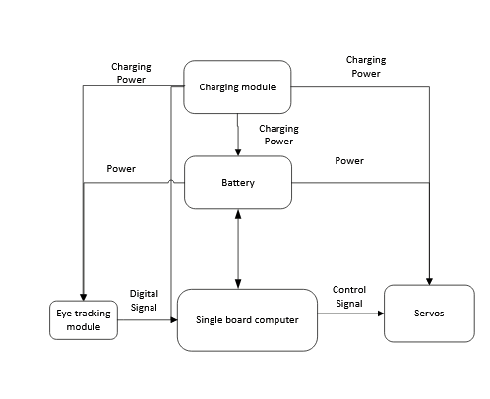

Activity Diagram:
